KWAME NKRUMAH UNIVERSITY OF SCIENCE AND TECHNOLOGY KUMASI, GHANA


COLLEGE OF ENGINEERING
DEPARTMENT OF ELECTRICAL/ELECTRONIC ENGINEERING
COE 381 (MICROPROCESSORS)
SOLAR POWERED AUTOMATIC PLANT WATERING SYSTEM

GROUP MEMBERS
- ABASS OSMAN - 7340923
- ADU SERWAH STEPHANIE – 7341423
- GIDEON AWONTEME ASIAK – 7342623
- ADU RAPHAEL OFORI – 7341323
- AVEVOR KAFUI - 7342723
- SIAW PRINCE AMPONSAH - 1874422

DATE: APRIL 4TH, 2026

ACKNOWLEDGEMENT
We thank God for good health in strength and in mind for taking us through this project from start to finish.

ABSTRACT
This project is a tinker cad design of a simple yet very helpful and economical solar powered plant watering system. It uses simple components to achieve this.

Contents
ACKNOWLEDGEMENT 2
ABSTRACT 2
LIST OF FIGURES 4
CHAPTER ONE 5
INTRODUCTION 5
1.1 STATEMENT OF PROBLEM 5
CHAPTER TWO 6
METHODOLOGY 6
2.1 COMPONENTS USED FOR IMPLEMENTING THE PROJECT 6
CHAPTER THREE 9
CONCLUSION 9
CHAPTER 4 10
RECOMMENDATION 10

LIST OF FIGURES
Figure 1: Arduino Uno controller……………………………………….………………...…..6
Figure 2: Soil moisture sensor………………………………………………………………...6
Figure 3: Pv panel………………………….……………...……………………………….….7
Figure 4: Wiring connections…………………………...………...……...……………………7

CHAPTER ONE

INTRODUCTION
  - STATEMENT OF PROBLEM
Traditional methods of plant irrigation, such as manual watering or fixed-timer systems, are often inefficient and labour-intensive. These methods do not account for real-time soil conditions, frequently leading to water wastage through over-irrigation or crop stress due to under-watering. Furthermore, many gardening environments lack easy access to the electrical grid, necessitating a self-sustaining power solution. This project addresses these challenges by designing and implementing a Solar-Powered Automatic Plant Watering System controlled by an Arduino microcontroller.
The project aims to solve the following specific technical and operational problems:
- Resource Inefficiency: Traditional "morning and evening" watering schedules do not adapt to fluctuating environmental needs. This project seeks to optimize water and power consumption by delivering moisture only when sensors indicate a specific dryness threshold.
- Power Autonomy: In off-grid or outdoor settings, maintaining a consistent power supply is difficult. This project implements a solar-harvesting circuit to ensure the Arduino and water pump operate independently of the main power grid.
- Sensor-Driven Accuracy: To move beyond human guesswork, the project evaluates whether soil moisture sensor data provides a sufficiently reliable metric to automate irrigation accurately, ensuring plants receive the precise amount of water required at any given moment. PROJECT OBJECTIVES
The goals of this project are to.
- Use water for garden more efficiently to save money
- Minimize labour required to irrigate garden.
- Promote use of clean energy for farming/gardening
- Obtain a good score at the end of the course evaluation

CHAPTER TWO

METHODOLOGY

2.1 COMPONENTS USED FOR IMPLEMENTING THE PROJECT

1. Arduino uno

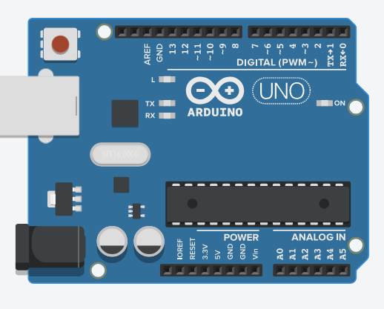
Figure 1 Arduino Uno microcontroller

2. Soil Moisture Sensor

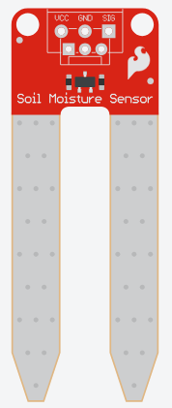
Figure 2 Soil moisture sensor

3. Solar pv

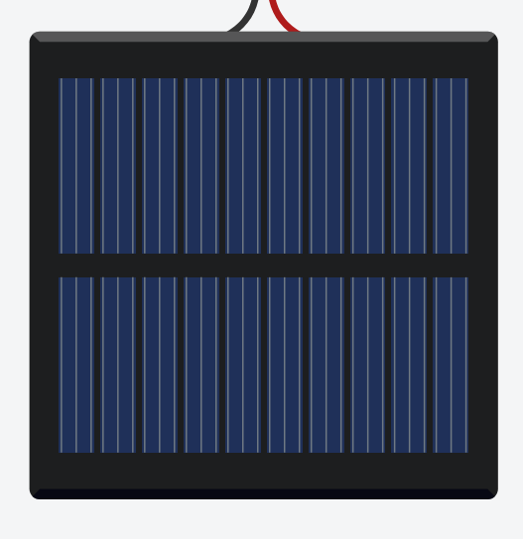
Figure 3 Pv panel

4. Motor pump
5. Relay
6. connecting wires
7. PV batteries
8. Push buttons
2.2 BREAKDOWN OF PROJECT SIMULATION IN TINKERCAD
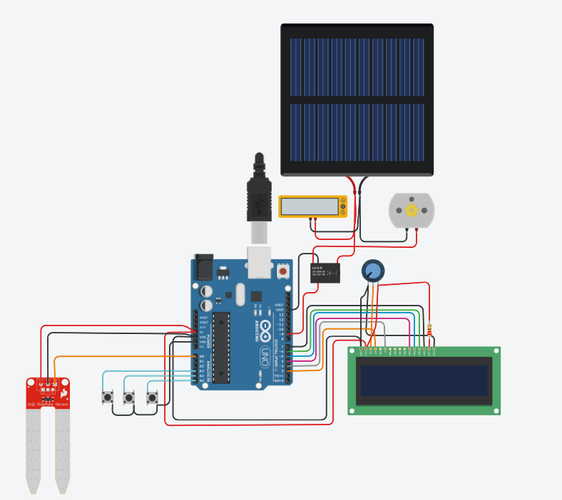
Figure 4 Wiring connections

The entire project was designed and implemented in tinkercad, the circuit connections is shown in the picture above.

The soil moisture sensor’s analogue output is connected to A0 on the Arduino and is used to receive voltage signals corresponding to soil moisture level.

Water pump is controlled via relay using analogue pin 9 by controlling the power from the solar pv to the motor pump.

The push buttons whose input are received at digital pins A3, A4 and A5 are used to regulate the threshold value in the EEPROM of the microcontroller. Push button 1 increases the threshold value by 1, push button 2 reduces the threshold value by 1 and push button 3 resets the original threshold value.

The LCD displays information about the system status. It shows when the pump is on/off, it also displays the moisture percentage. A potentiometer is connected to the LCD for the convenience of controlling display brightness.

Solar panel is used to drive the water pump, the microcontroller, Arduino in this situation controls the how much the pump delivers water to the soil.

The voltmeter is used to display how much energy is generated from the solar pv.

2.3 TESTING AND OBSERVATION
The system was tested in Tinkercad by simulating different soil conditions:
- Dry soil simulation triggered the pump to turn on.
- Adding “water” (changing sensor value) turned the pump OFF.
- The solar panel successfully powered the circuit in the simulation.
The thresholds may need real-world calibration depending on soil type and sensor variation.

CHAPTER THREE

CONCLUSION
- The Solar Powered Automatic Plant Watering System was successfully designed and simulated using Tinkercad and Arduino. The system effectively monitors soil moisture and automates irrigation while being powered by renewable solar energy.
- It achieves the project objectives of efficient water usage, reduced labour, and promotion of clean energy. The visual LED indicators and serial monitoring provide clear feedback on system status. This project demonstrates the practical application of microprocessors in solving everyday agricultural challenges.

CHAPTER 4

RECOMMENDATION
For future improvements and real-world implementation, the following are recommended:
- Capacitive Sensor Upgrade: Replaces resistive probes with capacitive sensors to eliminate corrosion and ensure long-term hardware reliability.
- Water Reservoir Protection: Integrates an ultrasonic or float sensor to automatically disable the pump if the water tank is empty, preventing motor burnout.
- Deep Sleep Power Management: Programs the Arduino to enter a low-power "sleep" state between readings, significantly extending battery life during cloudy periods.
- Weather Intelligence (DHT11/22): Adds a temperature and humidity sensor to adjust watering volumes based on heat and evaporation rates.
- IoT Remote Monitoring: Upgrades the controller to an ESP32 or ESP8266 to allow real-time moisture tracking and manual pump control via a smartphone app.

